**MongoDB Assignment 2- Aggregation**

Atlanta Population

1.use db.zipcodes.find() to filter the results where city is ATLANTA and state is GA

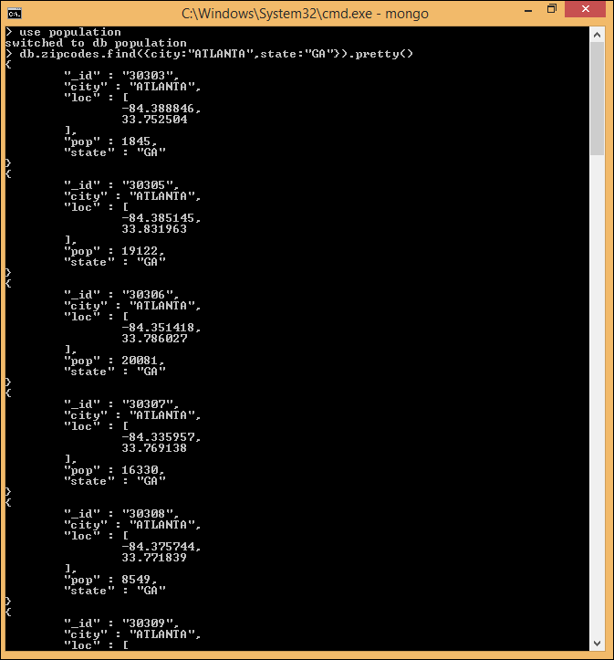

1. Use db.zipcodes.aggregate with $match to do the same as above

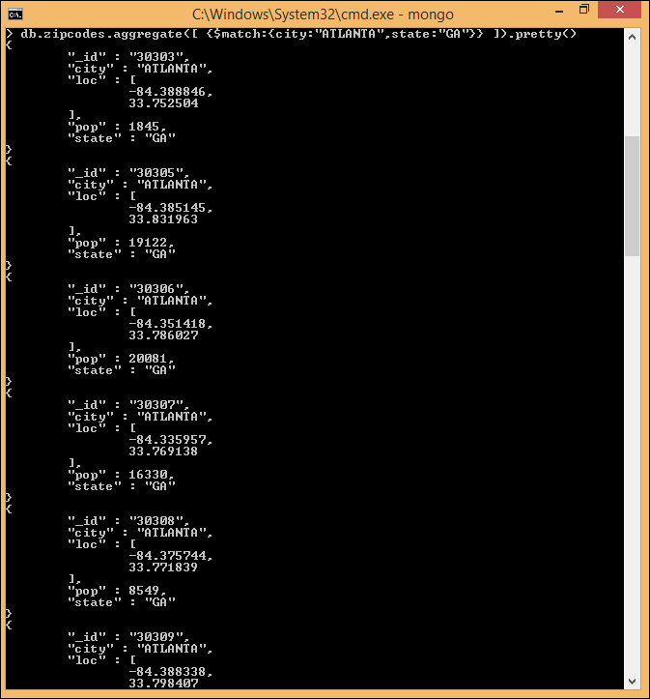

1. Use $group to count the number of zip codes in ATLANTA

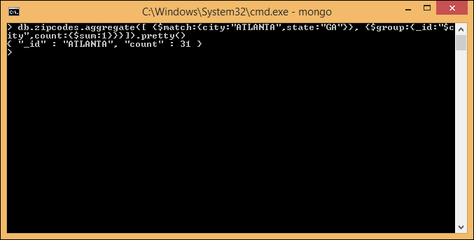

1. Use group to find the total popolation in the ATLANTA

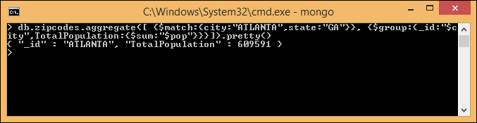

Population by state

1. Use aggregate to calculate the total population for each state

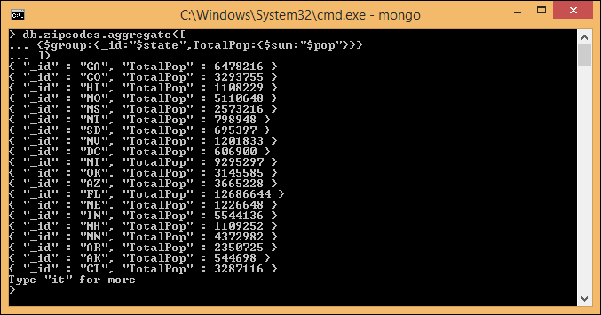

1. Sort the result by population highest first

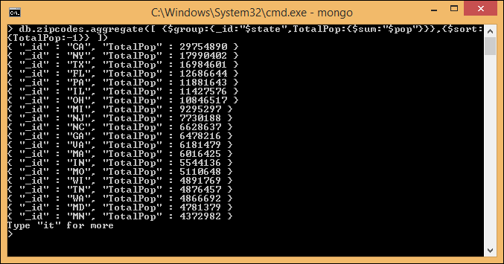

1. Limit the result to just first 3 results. What are the first 3 satates in population.

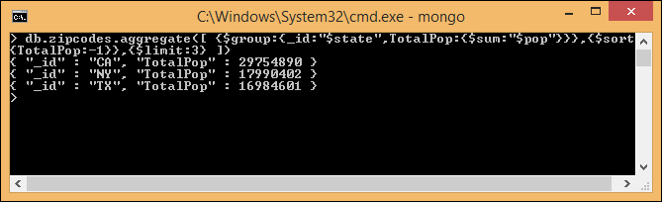

Population by City

1.

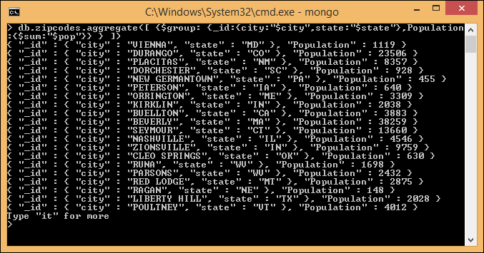

2.

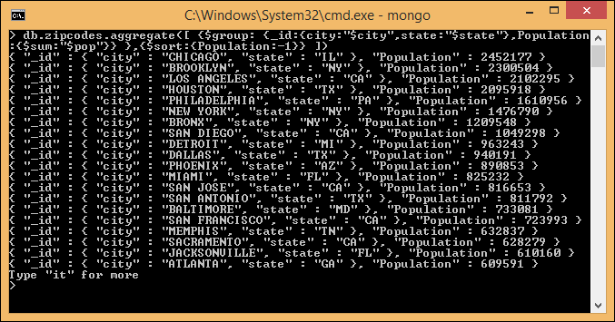

3.

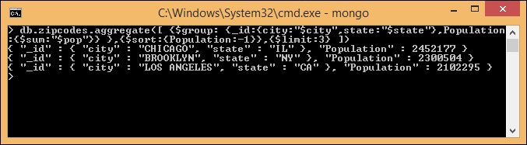

4.

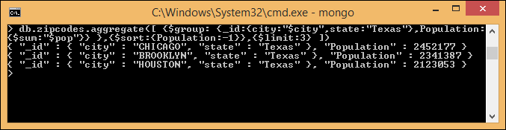

Bonus

1.

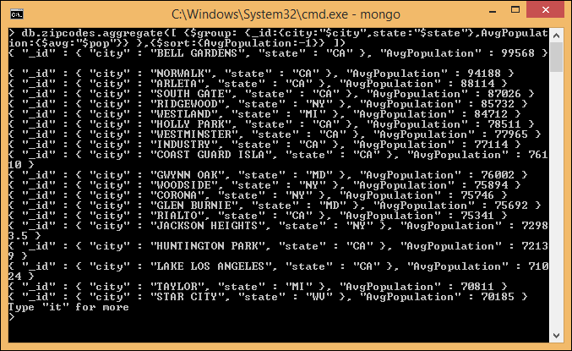

2.

